

**Zohaib Siddique**

**Roll No : 233517**

**BSCS-A**

**………………..**

Air University Multan Campus

**Lab -1**

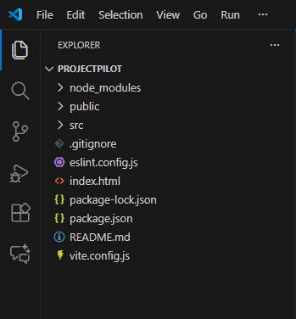

**Lab -2**

**Code :**

import { useState } from 'react'

import reactLogo from './assets/react.svg'

import viteLogo from '/vite.svg'

import './App.css'

function App() {

  const [count, setCount] = useState(0)

  return (

    <>

      <div>

        <a href="https://vite.dev" target="_blank">

          <img src={viteLogo} className="logo" alt="Vite logo" />

        </a>

        <a href="https://react.dev" target="_blank">

          <img src={reactLogo} className="logo react" alt="React logo" />

        </a>

      </div>

      <h1>Ready to React</h1>

      <div className="card">

        <button onClick={() => setCount((count) => count + 1)}>

          count is {count}

        </button>

        <p>

          Edit <code>src/App.jsx</code> and save to test HMR

        </p>

      </div>

      <p className="read-the-docs">

        Click on the Vite and React logos to learn more

      </p>

    </>

  )

}

export default App

**Output :**

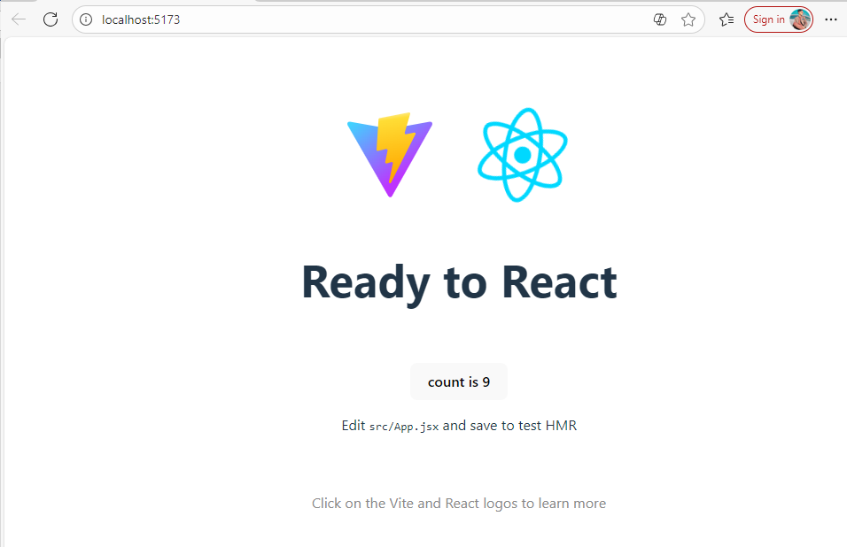

**Lab -3**

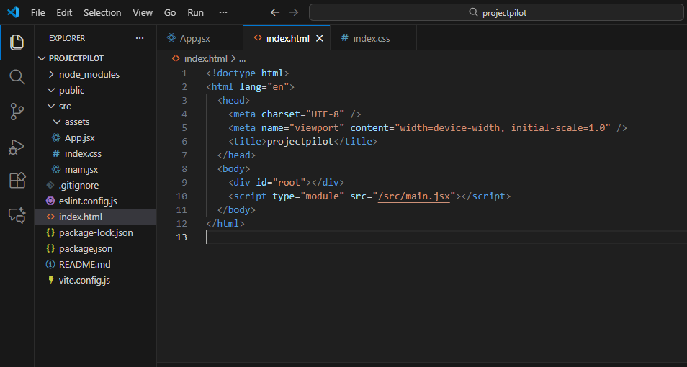

**Output :**

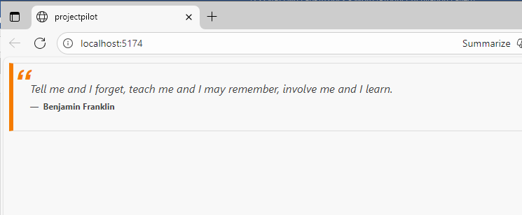

**Lab -4**

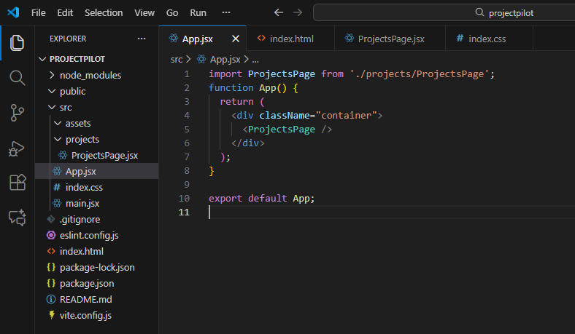

**Output :**

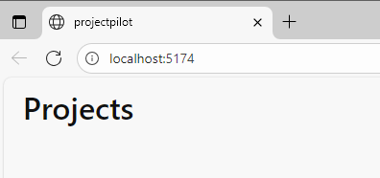

**Lab -5**

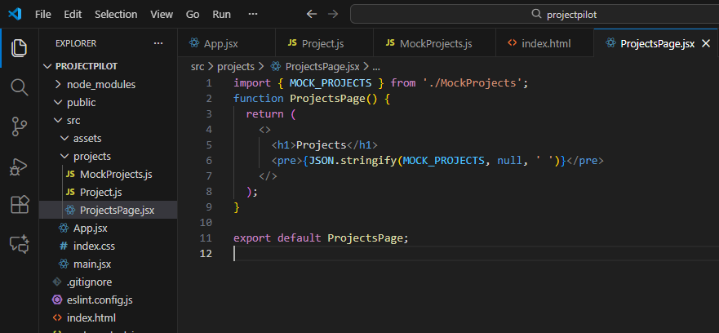

**Output :**

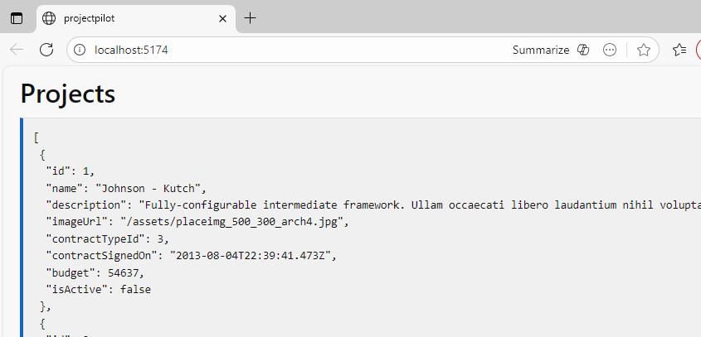

**Lab -6**

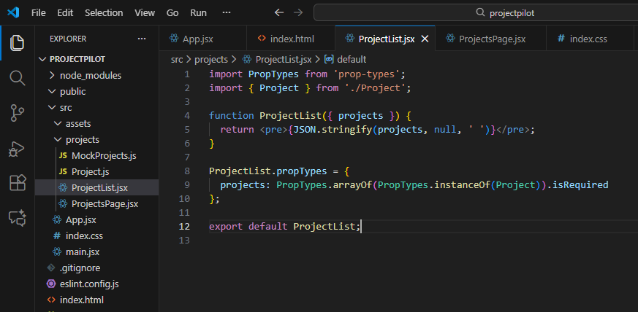

**Output :**

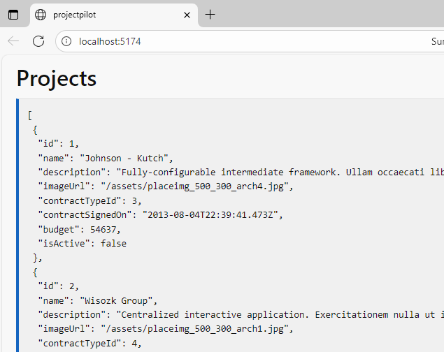

**Lab -7**

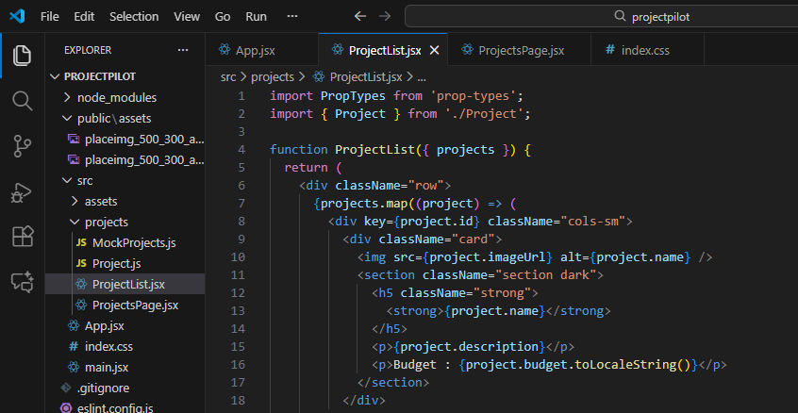

**Output :**

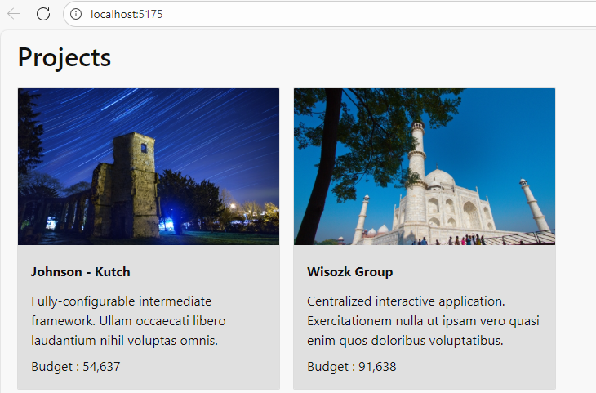

**Lab -8**

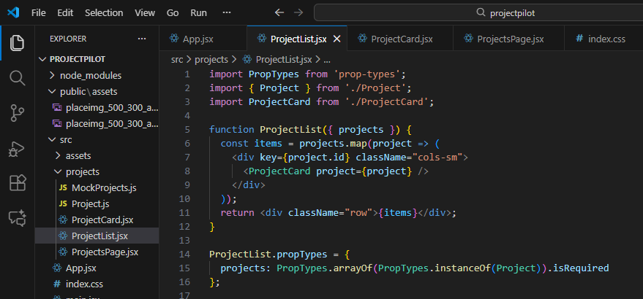

**Output :**

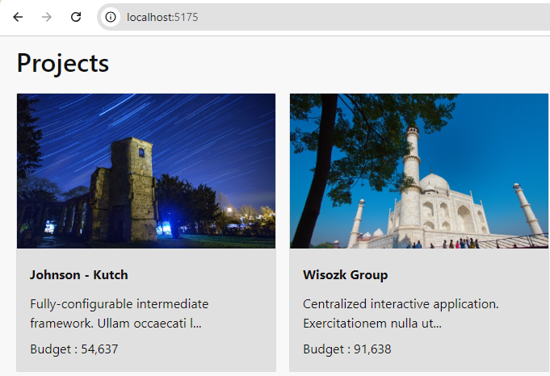

**Lab -9**

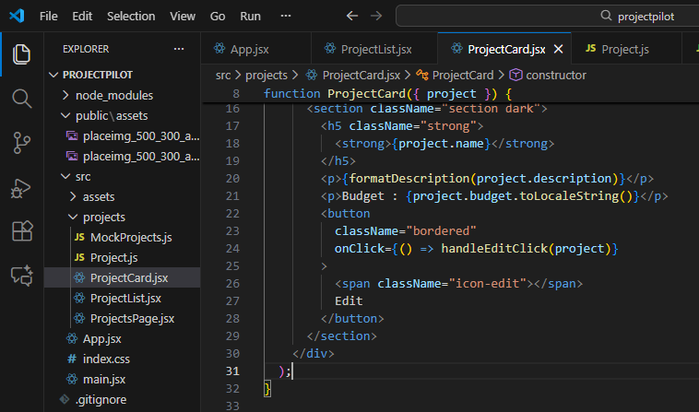

**Output :**

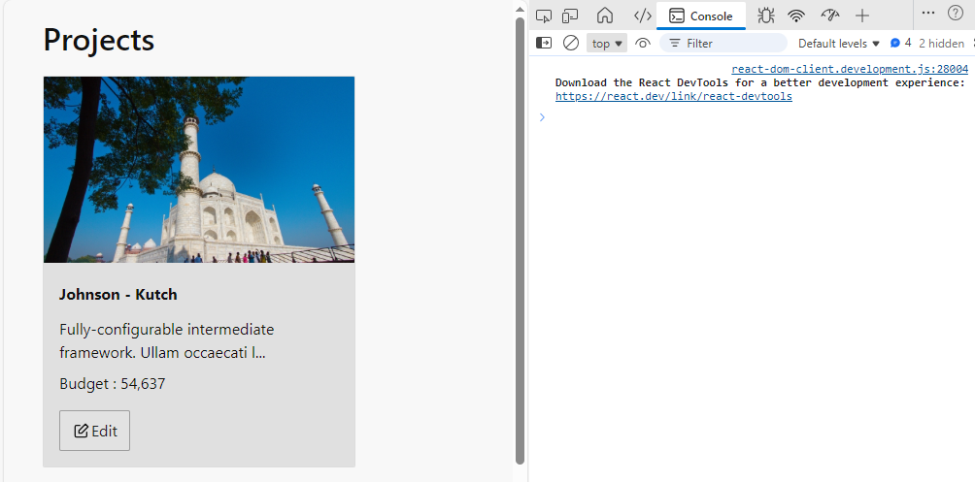

**Lab -10**

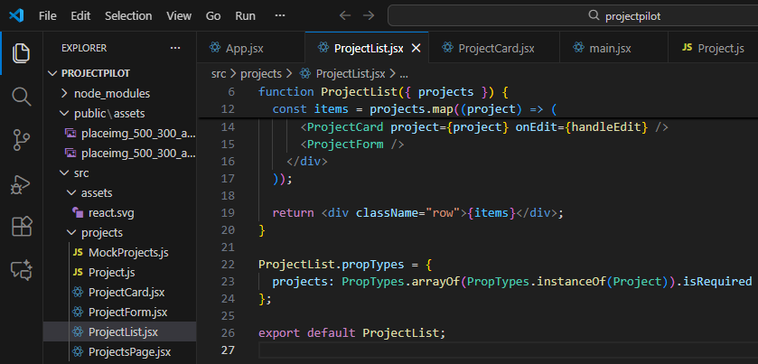

**Output :**

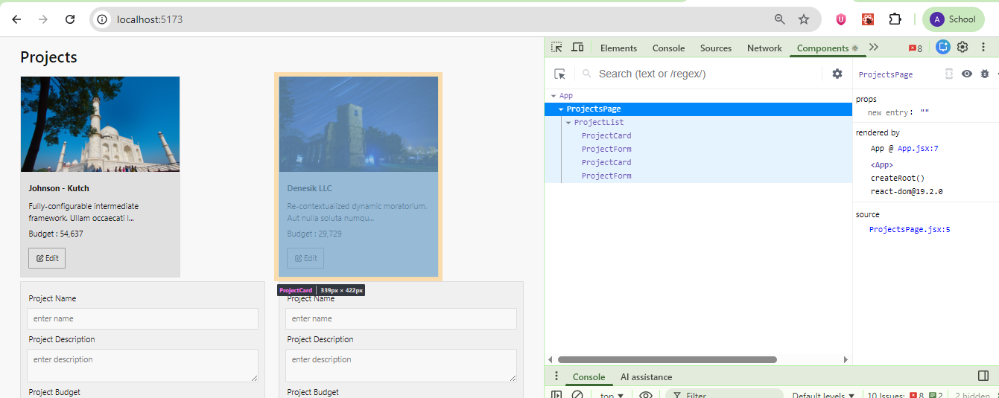

**Lab -11**

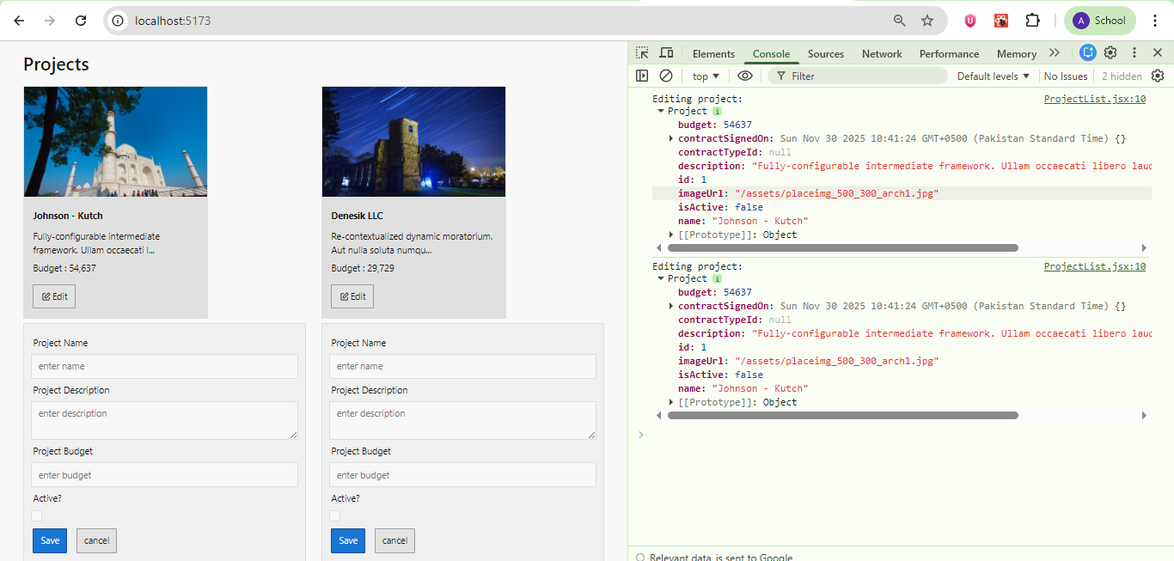

**Lab -12**

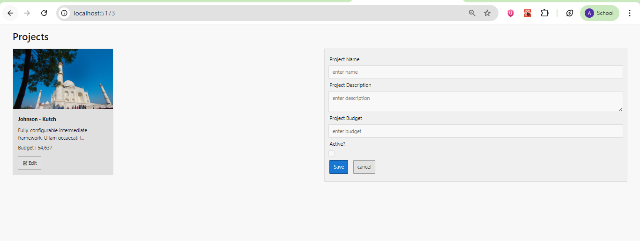

**Lab -13**



**After Cancel :**

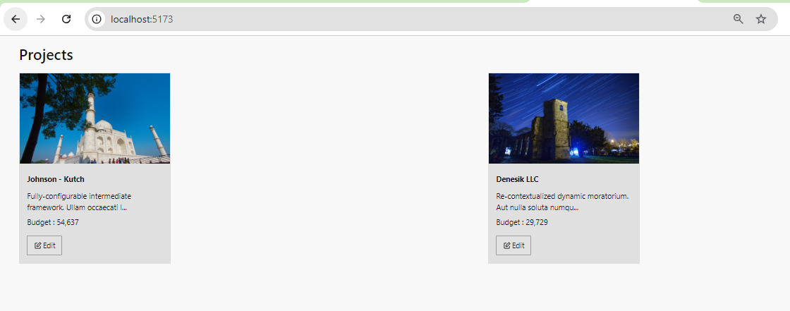

**Lab -14**

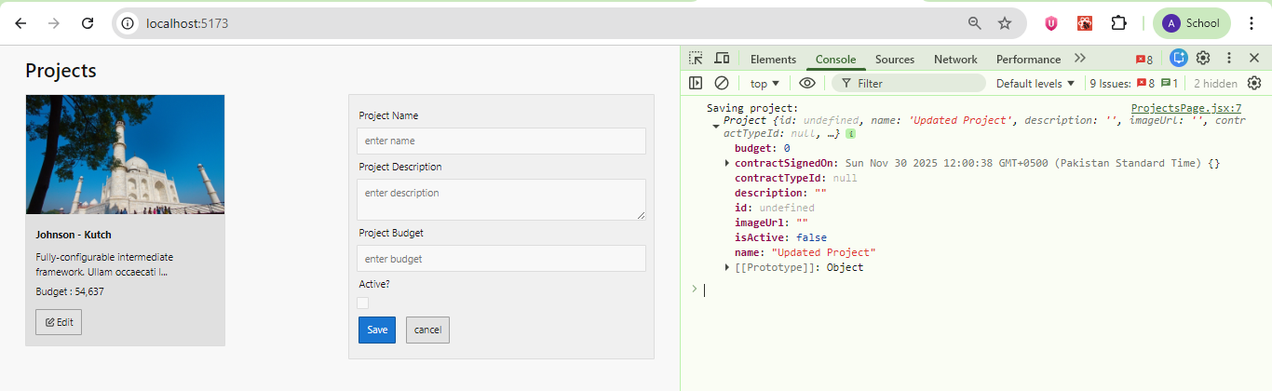

**Lab -15**

**Edit the Form :**

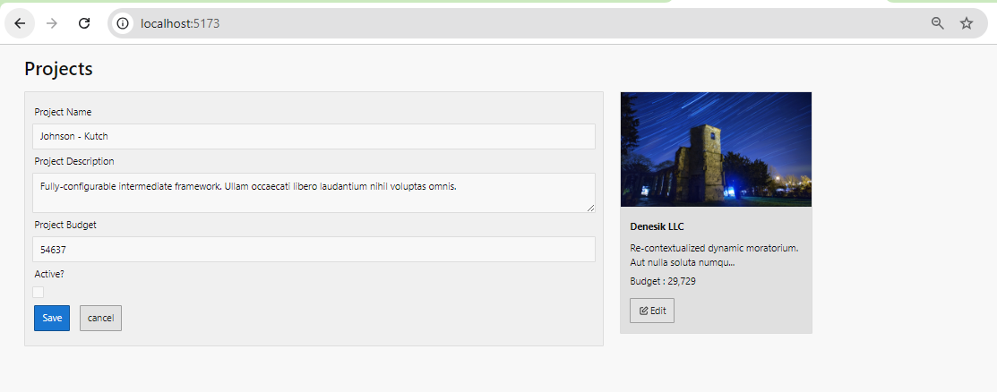

**Save the New Values :**

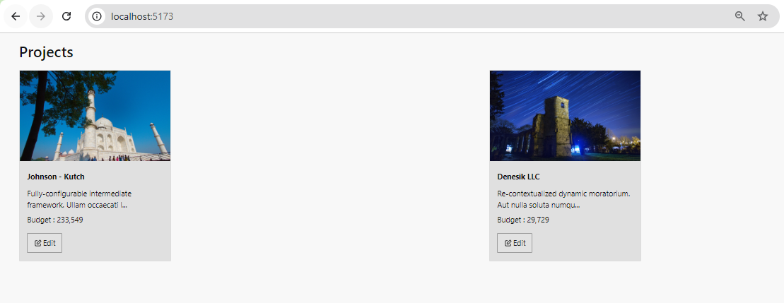

**Lab -16**

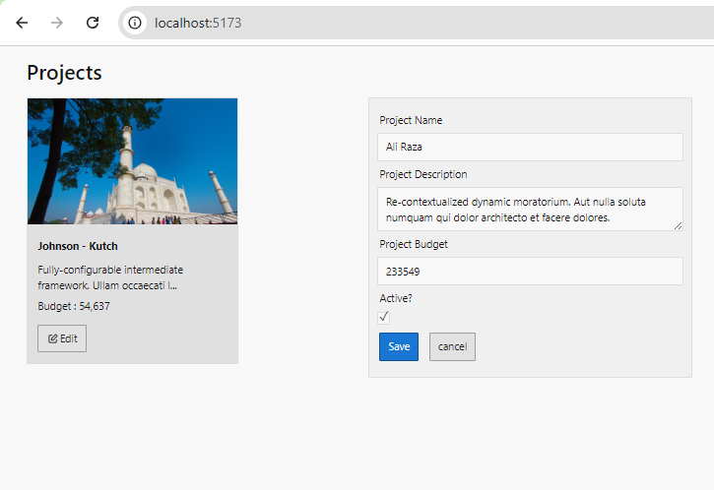

**Perform Testing :**

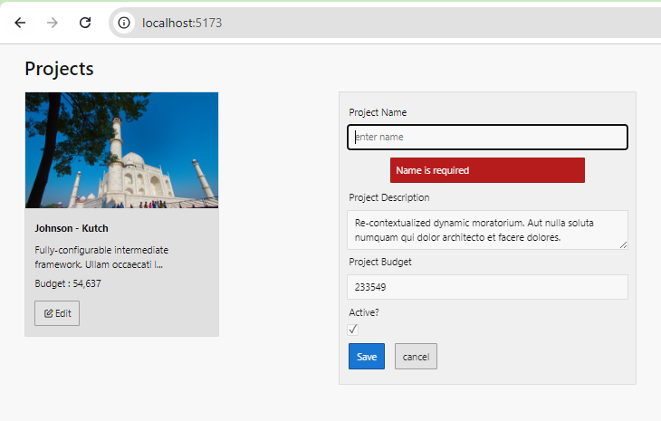

**Lab -17**

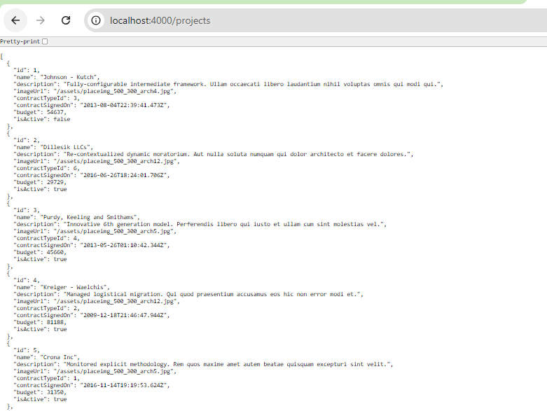

**Lab -18**

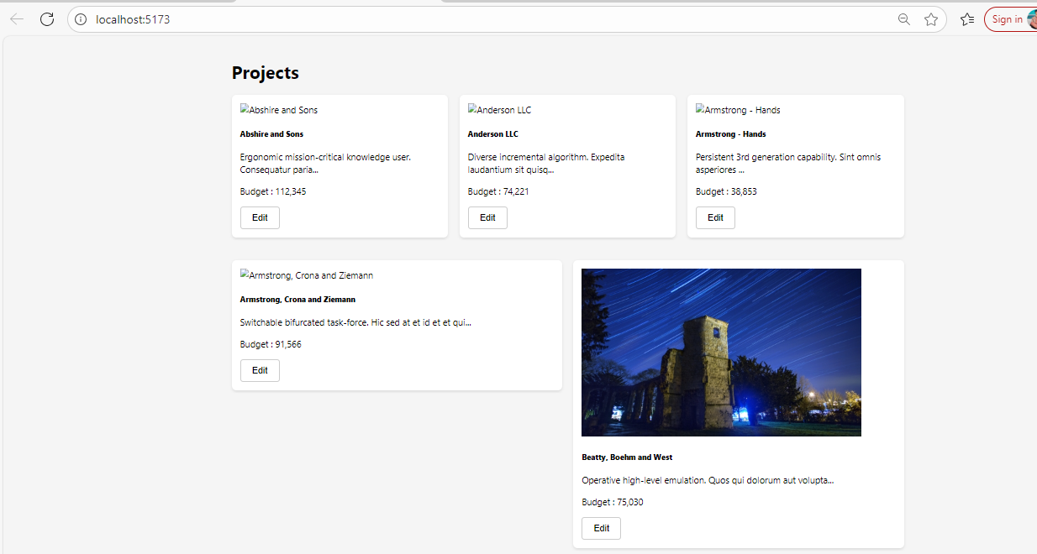

**Edit & All Pages:**

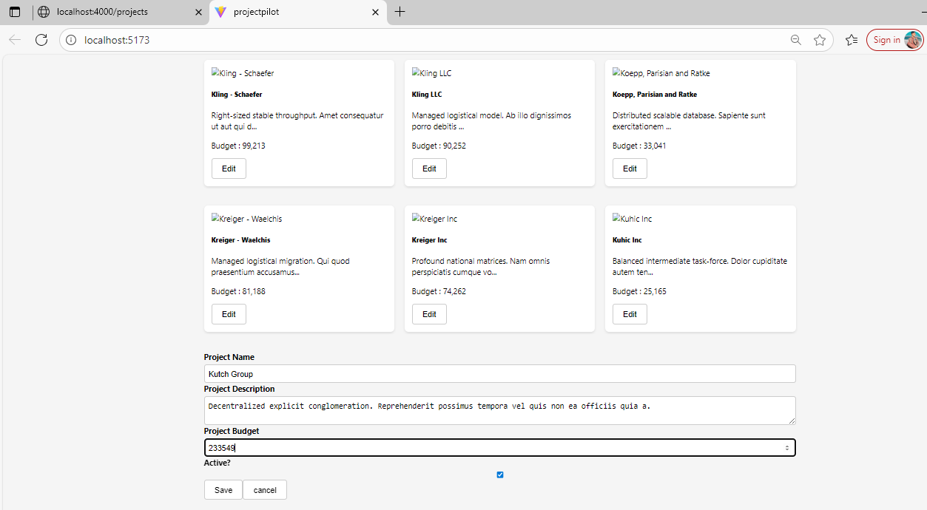

**Lab -19**

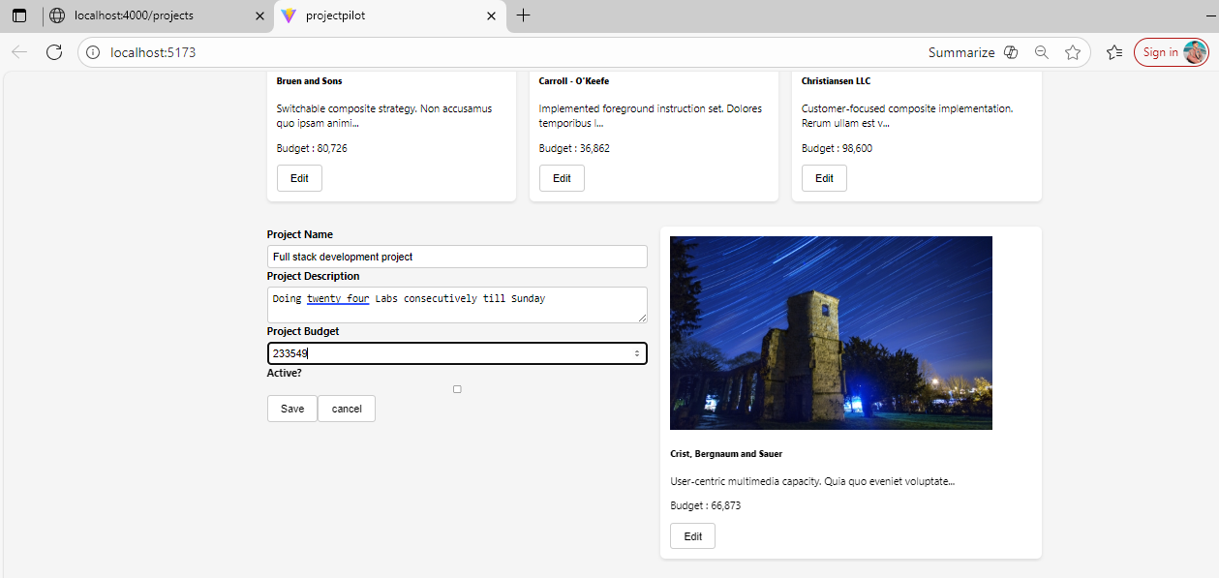

**Save Changings :**

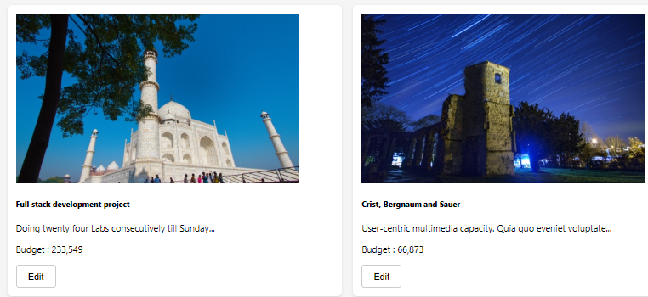

**Lab -20**

**Home Page Created:**

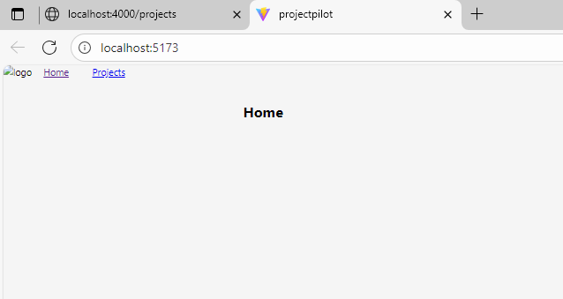

**Lab-21**

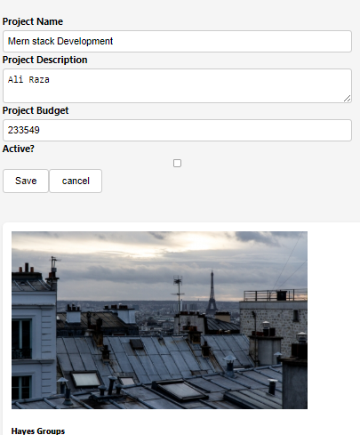

**After Updating :**

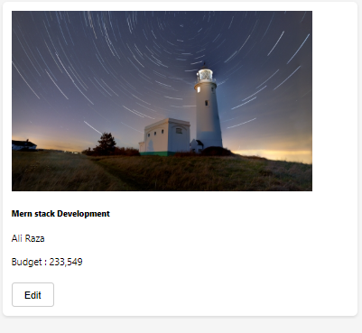

**Lab-21 (a)**

/* General reset and layout */

body {

  margin: 0;

  font-family: 'Segoe UI', Tahoma, Geneva, Verdana, sans-serif;

  background-color: #f5f5f5;

}

.container {

  max-width: 1200px;

  margin: 0 auto;

  padding: 20px;

}

/* Forms */

.input-group {

  margin-bottom: 15px;

}

.input-group.vertical {

  display: flex;

  flex-direction: column;

}

.input-group label {

  margin-bottom: 5px;

  font-weight: bold;

}

.input-group input,

.input-group textarea,

.input-group select {

  padding: 8px;

  font-size: 1rem;

  border: 1px solid #ccc;

  border-radius: 5px;

}

/* Buttons */

.button,

button {

  padding: 10px 20px;

  font-size: 1rem;

  border-radius: 5px;

  cursor: pointer;

}

.button.default {

  background-color: #e0e0e0;

  border: 1px solid #ccc;

}

.button.primary {

  background-color: #007bff;

  color: #fff;

  border: none;

}

.button.primary:hover {

  background-color: #0069d9;

}

.bordered {

  border: 1px solid #ccc;

  background-color: #fff;

}

/* Cards */

.card {

  background-color: #fff;

  border-radius: 8px;

  padding: 15px;

  margin-bottom: 20px;

  box-shadow: 0 2px 5px rgba(0,0,0,0.1);

}

/* Error Cards */

.card.error {

  background-color: #ffdddd;

  border-left: 5px solid #f44336;

}

.card.large.error {

  padding: 20px;

}

/* Centering for Loading Indicator */

html, body, #root, .container, .center-page {

  height: 100%;

}

.center-page {

  display: flex;

  justify-content: center;

  align-items: center;

  flex-direction: column;

}

/* Spinner */

.spinner {

  display: inline-block;

  width: 50px;

  height: 50px;

  border: 5px solid rgba(0,0,0,0.1);

  border-radius: 50%;

  border-top-color: #007bff;

  animation: spin 1s ease-in-out infinite;

}

@keyframes spin {

  to { transform: rotate(360deg); }

}

/* Project List */

.row {

  display: flex;

  flex-wrap: wrap;

  gap: 20px;

}

.cols-sm {

  flex: 1 1 calc(33.333% - 20px);

}

.col-sm-12 {

  flex: 1 1 100%;

}

/* Button group */

.button-group {

  display: flex;

  justify-content: flex-start;

}

.button-group.fluid .button {

  flex: 1;

}

/* Icon Alert (used in error messages) */

.icon-alert {

  display: inline-block;

  width: 16px;

  height: 16px;

  margin-right: 5px;

  background-color: #f44336;

  border-radius: 50%;

}

.icon-alert.inverse {

  background-color: #fff;

  border: 2px solid #f44336;

}

**Lab-21 (b)**

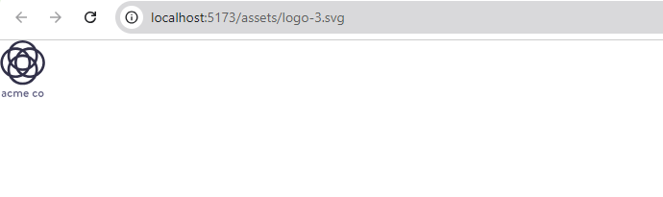

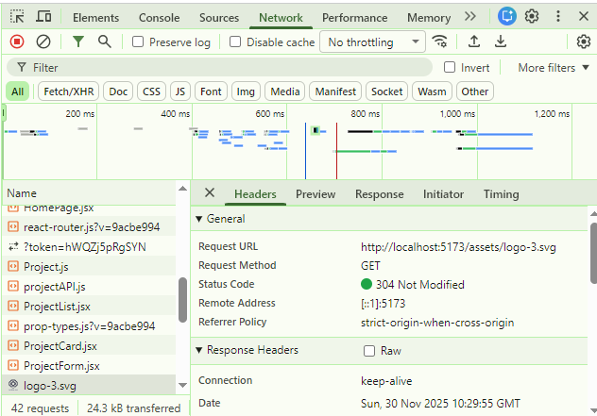

**Lab-21 ©**

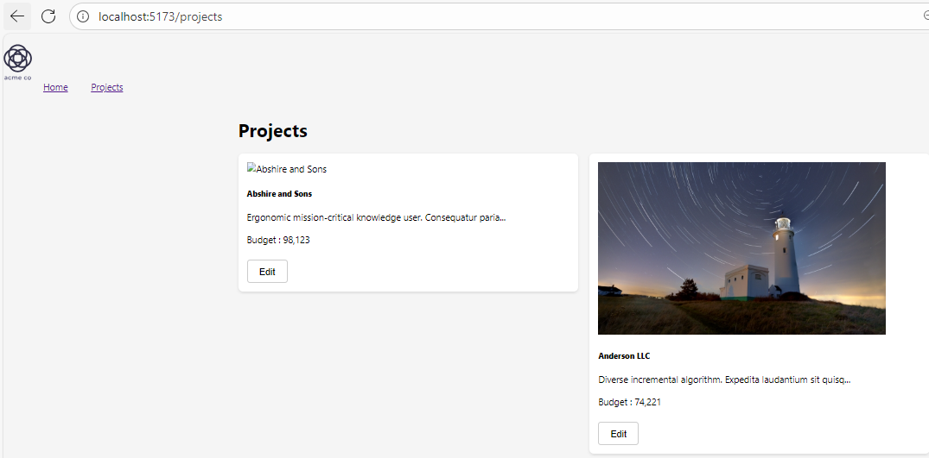

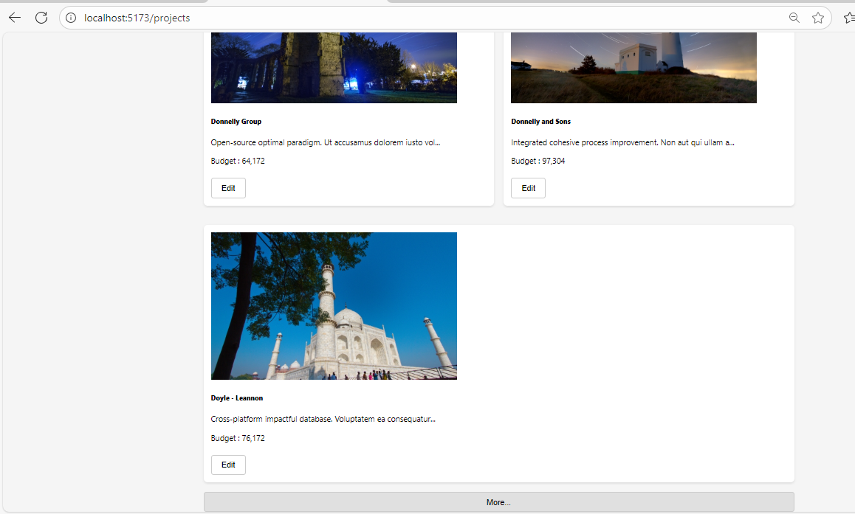

**Lab-22**

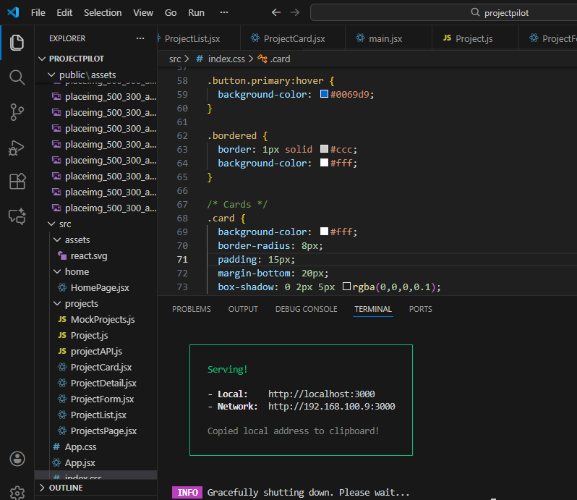

**Lab-23**

* The backend API Are shut down

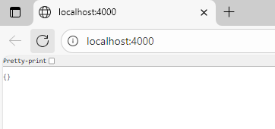

**Lab-24**

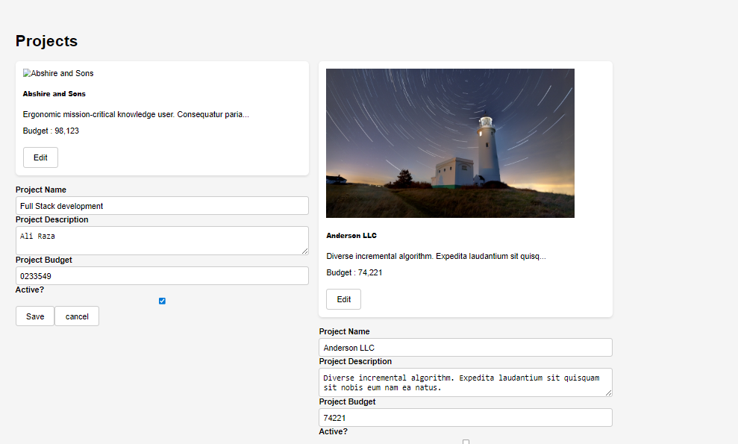

**Record Updating :**



